NLGen2: A Linguistically Plausible, General Purpose
Natural Language Generation System
by Blake Lemoine
Center for Advanced Computer Studies
UL, Lafayette
August 9, 2009

Introduction
Natural language generation (NLG) is the computational task of transforming information from a semantic representation form to a surface language representation form. Historically there has been some interest in psychologically plausible NLG (Shieber 1988), but most popular generation systems (Reiter and Dale, 2000) deviate from this methodology to varying degrees. This paper outlines what it would mean for an NLG system to be linguistically plausible, which is a prerequisite to psychological plausibility. It then goes on to present linguistic and psycholinguistic theories upon which to base a linguistically plausible NLG system. Finally it outlines NLGen2, a natural language system based upon those theories.

Background
NLGen2 is the counterpart to RelEx (Relationship Extractor) within the OpenCog framework (Hart and Goertzel 2009). The OpenCog framework is an open-source project with general artificial intelligence as its goal. It contains modules for various types of reasoning and knowledge management. RelEx is a natural language processing module that has Carnegie Melon's Link Parser (Sleator and Temperley, 1995) at its core. Link Parser is weakly equivalent to standard context-free parsers. Unlike standard parsers, however, it forms binary links between words rather than forming the trinary relationships found in parse trees. This difference makes it operate much faster in practice than standard parsers; however, it is still possible to perform post-processing on Link Parser’s output to construct a standard parse tree. RelEx performs post-processing on Link Parser’s output to extract semantic tuples corresponding to the parsed links. The specific format of RelEx’s output is determined by which of its output views is selected.
NLGen is the current natural language generation module used within the OpenCog framework. It implements the SegSim approach developed by Novamente (OpenCog Wiki, 2009). This methodology performs language generation by matching portions of propositional input to a large corpus of parsed sentences. From the successful matches it finds, it constructs syntactic structures similar to those found in the corpus. The advantage of NLGen's approach is that it is very fast for simple sentences. Its limitation is that it cannot generate complex sentences in a practical amount of time. Also, because of its reliance on a corpus, it is incapable of forming sentences with syntactic structures not found in the corpus. NLGen2 overcomes the scaling limitation by using a psychologically realistic generation strategy that proceeds through symbolic stages from concept to surface form. It overcomes the knowledge limitation by using Link Parser's dictionary as its knowledge source rather than a pre-parsed corpus.

Linguistic Plausibility
Strong equivalence between human psychology and artificial intelligence systems is a long term goal set by prominent researchers in both natural language processing and cognitive science (Shieber, 1988; Newell, 1990). If two computational systems have the same functional architecture and achieve the same semantic input/output conditions using the same algorithms, then the two computational systems are strongly equivalent (Pylyshyn, 1986). NLGen2 does not meet such strong criteria as these, but attempts to approach them by meeting the requirements for linguistic plausibility as defined below.
Linguistic and psycholinguistic theories attempt to describe the faculty of human language in an accurate manner. Different linguists concentrate on different levels of abstraction in their theories, but they all are attempting accurately to reflect some aspect of psychological reality, specifically, the human language faculty. Therefore, if a linguistic theory is in fact correct, then the theory will describe that particular aspect of psychological reality. By extension, any computational system that correctly implements a linguistic theory is as psychologically realistic as that theory. Implementing a plausibly correct linguistic theory in an effort to approach psychological reality is referred to here as linguistic plausibility.

Theoretical Basis
Levelt's (1989) model of language processing, shown in Figure 1, is the large scale theory of language production upon which NLGen2 is based. It is highly modular and contains multiple feedback loops. NLGen2 primarily corresponds to the portion labeled as the “formulator.” Each module in Levelt's model is a very specialized symbol transformer. The conceptualizer transforms communicative intentions into pre-verbal messages, a symbolic representation which is the propositional information required to linguistically produce a single concept or intention. The formulator is the module that transforms preverbal messages into articulation plans, the instructions required to speak or write the linguistic output. Finally, the articulator transforms articulation plans into physical action. The formulator is the portion of this model concerned with the type of processing traditionally seen as syntactic processing, the primary interest of this paper.

Figure 1. Levelt's Model of Language Processing
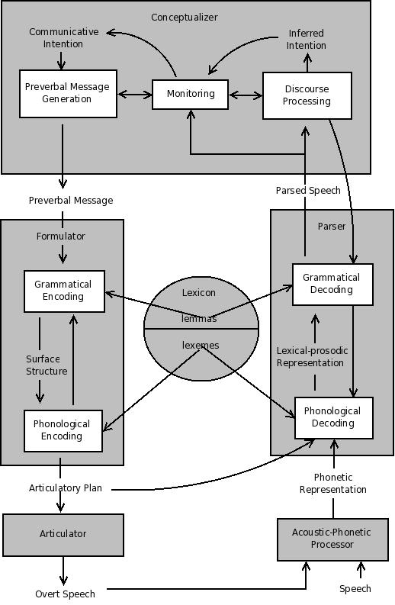
Prima facia, syntax is the study of the combination of linguistic objects, whatever they might be, into larger linguistic objects. The Minimalist Program (Chomsky 1995) makes the claim that the only type of linguistic object relevant to syntactic processing is the “syntactic object” (SO). SOs represent information that is in the process of being transformed from a conceptual and intentional form into a phonetic one. They are described by Chomsky as “rearrangements of properties of the lexical items of which they are ultimately constituted” (Chomsky 1995, p. 226). Within this context, lexical items are entries from the mental dictionary that contain substantive semantic content. These linguistic objects may then be combinaed to form larger linguistic objects which can then be combined themselves into larger units.
The simplest formulation of the combining process is the operation “merge” (Chomsky, 1995), an operation that takes two operands, α and β, from a general pool of linguistic items called the “numeration” and builds from them some phrase K constituted from α and β. Chomsky states that K must involve at least the set {α, β} because it is the simplest object that can be constituted from the two. He goes on to reason that, because the combination of α and β may have different properties from α and/or β, there must be included some element indicating the properties of K. These restrictions mean that the simplest form of the result will be K {γ, {α, β}} where γ identifies the type of K. The simplest possible content of γ is either α or β. Whether α or β is chosen as the new type depends on which of the two syntactically dominates the other. Syntactic domination, in this sense, is the same as the head projection. The head of a phrase is the constituent that determines what type of phrase it is. Therefore the projecting head of a noun phrase is the noun, of a verb phrase is the verb and so forth.
Culicover and Jackendoff (2005) argue that the actual phrase structure is flatter than the one proposed by Chomsky (1995). They argue that the empirical data motivates changing merge from an operation that produces binary branching structures to one that produces n-ary branching ones. Chomsky's formulation of merge strictly adheres to the binary branching hypothesis (Guevarra, 2007). Jackendoff and Culicover, on the other hand, provide numerous examples where allowing an n-ary branching structure makes the theory both simpler and better able to account for the empirical data. This different branching structure changes merge from the operation “merge(α, β) = {γ, {α, β}}” to “merge({γ₁, α₁}, β₂) = {γ₂, {{γ₁, α₁}, β₂}} or merge({γ₁, α₁}, β₂) = {γ₂, α₁ ⋃ {β₂}}”. The two merge equations which is ultimately chosen is determined by the nature of merge's operands.
Chomsky (1995) additionally proposes the operation select, an operation which determines what order items in the numeration undergo merger. As described by Chomsky, select has the effect of significantly reducing the number of possible combinations a natural language production system examines. Chomsky makes very few stipulations as to exactly how select should function. Culicover and Jackendoff (2005), however, provide some insights as to which mergers are potentially examined. The two constraints they propose are satisfiability and consistency. Satifiability states that there may not be a syntactic structure which is ungrammatical and also cannot be made grammatical by any amount of linguistic processing. In other words, the human language faculty simply does not allow dead end transformations to be explored. The constraint of consistency states that at all times the syntactic structure must conform to all relevant requirements. This constraint precludes the possibility of proceeding through an inconsistent state in order to get to a consistent one. During language production, any merger that would break one of these principles will not be examined.
In Chomsky's initial formulation of merge (Chomsky, 1995), the resultant item K was immediately returned to the numeration. Later work (Chomsky, 2005) modified this portion of merge by introducing the concept of “phases.” A phase is a group of merge operations, the exact nature of which is a current source of heated theoretical debate. The later theory postulates that merge will continue iteratively building on the same object until a phase has been completed. Only once a phase has been completed is the result of the merger operations returned to the numeration. The primary change to merge that this causes is that select only provides one of the two operands to merge. The other operand is either the result of the previous merger if a phase has not been completed yet, or null if the result of the previous merger was returned to the numeration as a completed phase.
Later work in the Minimalist Program has also argued that the result of merge does not have a specified linear order. Merge is therefore much more like a Calder mobile than it is like a traditional syntax tree (Lasnik and Uriagereka, 2005). The linear order of a syntactic object must be specified by a separate process. Chomsky (2005) suggests that linearization should be performed when a phrase is completed. Linearize must create a linear order for the constituents that is consistent with their hierarchical structure. Other than this constraint, Chomsky leaves the specification of linearize as a topic of current research.

Data Structures
NLGen2 has three major data structures, two of which are information bearing and one which is architectural. Information-bearing data structures are the “pre-verbal messages” (PVM), named after Levelt's pre-verbal messages, and the “current syntactic object” (CSO), named after Chomsky's conception of linguistic objects. NLGen2's modules communicate via a data structure called the “verbalization buffer.” These data structures along with NLGen2's algorithms make up the architecture illustrated in Figure 2.

Figure 2. General Architecture of NLGen2
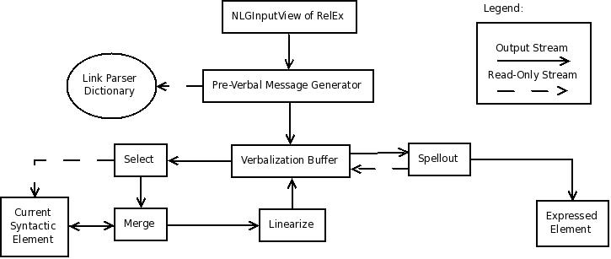

PVMs are composed of a set of propositions representing the message's semantic content and a link structure, (Sleator and Temperly, 1995) representing the message's syntactic content. The set of propositions will have exactly one “lemma” proposition of the form “lemma(n, x)”, where n is a unique identifier and x is a string representation of the word that corresponds to that message. Any time that unique identifier appears in a proposition, whether in that PVM or a different one, the proposition is interpreted to refer to the PVM that has that identifier in its lemma proposition. All other propositions found in PVMs operate as standard semantic tuples such as RDF (Klyne and Carroll, 2003), OWL (Bechhofer et.al. 2004), or RelEx propositions (Fundel et.al. 2007).
Link structures (Sleator and Temperly, 1995) compose the other half of a PVM's informational content. They are represented in NLGen2 as trees composed of “lemma”, “and”, “or”, and “leaf” nodes, as well as a mechanism to indicate how often particular portions of the link structure are used. Links are formed between words in a sentence and serve to differentiate the various types of relationships that two words may have with each other. For instance the “S” link relates a verb to its subject, and the “MV” link relates a verb to some type of modification of that verb. Similar to a preverbal message’s proposition set, the link structure will have a single “lemma(x)” node as the tree’s root, where x is the lemma's unique identifier in that preverbal message.. All other nodes in the tree will be either “and” nodes, “or” nodes, or leaf links. Link structures are designed by the link grammar dictionary writers such that a grammatical construction has been formed if and only if all link structures of all involved lemmas are satisfied, as defined below.
A grammatically correct link structure is one that has been “satisfied.” A link structure is satisfied if and only if the root of the link structure is satisfied. A leaf link is satisfied if and only if that link has been successfully realized between two words in a sentence. A lemma node may have exactly one child and is satisfied if and only if its child is satisfied. An “and” node may have any number of children and is satisfied if and only if all of its children are satisfied. An “or” node may also have any number of children, but is satisfied if and only if exactly one of its children is satisfied. The concepts of link structure satisfaction, whether or not a link structure has been satisfied, and satisfiability, whether or not a link structure may potentially be satisfied, play a significant role in the requirements placed on syntactic objects during the merger and linearization processes.
The current syntactic object is similar to a pre-verbal message in that it is composed of a semantic proposition set and a syntactic link structure. The primary difference is that there may be multiple lemma propositions in the current syntactic object's proposition set, and the current syntactic object's link structure may have multiple lemma nodes. This difference facilitates the possibility that a syntactic object may be composed of multiple pre-verbal messages. The only other difference between the CSO and PVMs is that NLGen2 only ever has a single CSO at any given time, whereas it may have as many PVMs as the verbalization buffer may hold.

Input and Preverbal Message Generation
The input to NLGen2 is the output from the NLGInputView of the RelEx system. This format of RelEx output contains the propositions representing the semantic content of a sentence or phrase, as well as propositions representing syntactically relevant information. In order to perform syntactic processing on these propositions, they must be converted into preverbal messages. The first step in this process, performed by the preverbal message generator, is to consult Link Parser's dictionary to get the link structures associated with each lemma.
A pre-verbal message is generated once a lemma is successfully found in Llink Parser's dictionary. A pre-verbal message is built from the link structure for a lemma and the set of all propositions related to that lemma, including the lemma proposition itself. To illustrate this process, table 3 consists of the propositions generated by RelEx's NLGInputView for the sentence “Alice ate the mushroom with a spoon,” and table 4 contains the preverbal messages formed from this input. Because of the large size of link structures, only the links that will be relevant to this running example are illustrated.

Table 3. Propositional Input for “Alice ate the mushroom with a spoon”

lemma(1, ate) lemma(2, spoon) with(2, 4)
lemma(3, mushroom) _obj(1, 3) _subj(1, Alice)
tense(1, past) inflection-TAG(1, .v) pos(1, verb)
pos(., punctuation) inflection-TAG(2, .n) pos(2, noun)
noun_number(2, singular) pos(with, prep) pos(a, det)
DEFINITE-FLAG(3, T) inflection-TAG(3, .s) pos(3, noun)
noun_number(3, singular) lemma(4, Alice) DEFINITE-FLAG(4, T)
gender(4, feminine) inflection-TAG(4, .f) person-FLAG(4, T)
pos(4, noun) noun_number(4, singular) pos(the, det)

Table 4. Preverbal Messages for “Alice ate the mushroom with a spoon”
PVM1:  Propositions: {_subj(2, 1), DEFINITE-  FLAG(1, T), gender(1, feminine),  inflection-TAG(1, .f), person-FLAG(1,T),  pos(1, noun), noun_number(1,singular),  lemma(1, “Alice”)}  Links: Ss+ (Singular Subject, right) | PVM2:  Propositions: {_obj(2,3), _subj(2,1), tense(2,  past), inflection-TAG(2, .v), pos(2, verb),  with(2,4), lemma(2, “eat”)}  Links: S- (Subject, left)  O+ (Object, right)  MV+ (Verb modification, right)
PVM3:  Propositions: {_obj(2,3), DEFINITE-  FLAG(3, T), inflection-TAG(3, .s),  pos(3,noun), noun_number(3, singular),  lemma(3, “mushroom”)}  Links: O- (Object, left) | PVM4:  Propositions: {with(2,4), inflection-  TAG(4, .n), pos(4, noun), noun_number(4,  singular), lemma(4, “spoon”)}  Links: MV- (Verb modification, left)

Syntactic Object Generation by SELECT and MERGE
The current syntactic object is manipulated by MERGE. Its state at the beginning of processing is the empty syntactic object, containing an empty set of propositions and the empty expression as its link structure. Whenever MERGE is provided with a preverbal message by SELECT, it creates a new syntactic object by combining the current syntactic object with the given preverbal message. Through this mechanism NLGen2 forms phrases that have the semantic contents of their constituents and the appropriate syntactic behavior. The MERGE process mimics the functionality of the operation of the same name described in the Minimalist Program (Chomsky 1995).
The link structure is updated by examining the intersection of the two sets of propositions being merged. Any proposition that appears in both sets must correspond to a link that is formed between them. For instance, the proposition “_subj(2,1)” represents the subject relationship between the second and first lemmas. When the MERGE operation encounters this proposition in the intersection, it will create a link structure consistent with both of its operands' link structures that accounts for the fact that a subject link has been successfully formed by the proposition “_subj(2,1)”. Which proposition corresponds to which link is specified in data files used by RelEx in post processing. These files ensure that the same associations are made by NLGen2 as are made in its companion parser.
The proposition portion of a merger result is the union of the two operands' proposition sets with the intersection excluded. The semantic content represented by those propositions in the sets' intersection is now contained in the link structure and is therefore not needed in the proposition set. All other propositions, however, are still needed to represent the semantic content of the resultant syntactic object and are retained.
NLGen2's SELECT operation uses the semantic content of SOs in order to determine whether or not they are valid candidates for merger. Specifically, the proposition sets of two SOs must have a non-empty intersection to be selected. SELECT first examines the result of the previous merger which is stored in a special location called the current syntactic object (CSO), then examines each SO contained in the verbalization buffer, a storage location analogous to Chomsky's numeration. If the CSO is empty (in other words, if no mergers have yet been performed or the result of the previous merger has been returned to the verbalization buffer), then the first SO in the verbalization buffer is chosen for merger. If the CSO is not empty, then SELECT will iterate over the items in the verbalization buffer until it finds one that has a semantic proposition set that has a non-empty intersection with the CSO's semantic proposition set.
The input for the running example of “Alice ate the mushroom with a spoon” forms four preverbal messages. Four mergers are necessary to combine these into a single syntactic object that represents the sentence. The order of application of these four mergers is order independent; all information is retained by the merger process and can be reversed if necessary. Figure 5 illustrates one possible order for these mergers, one chosen on the basis of clarity.

Figure 5. Series of Mergers for “Alice ate the mushroom with a spoon.”
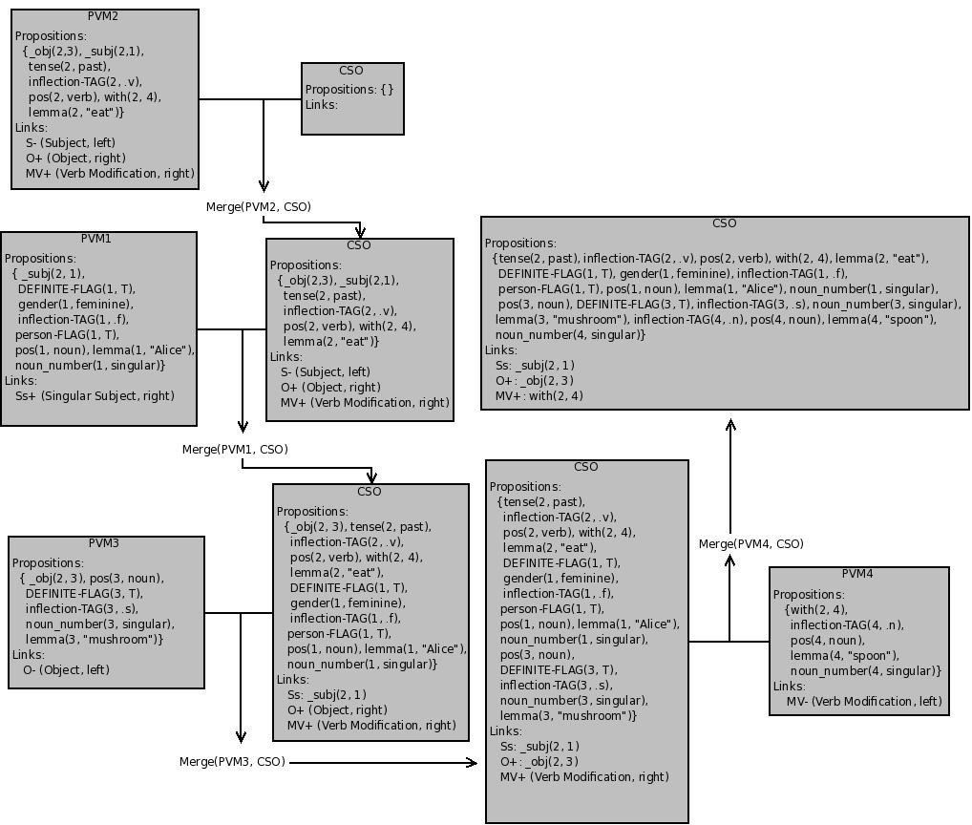
Syntactic Object Linearization
When there are no pre-verbal messages left in the verbalization buffer that are compatible with the CSO, it is linearized into a preverbal message and returned to the verbalization buffer. Linearization fixes the linear order of the link structure and reduces all lemmas contained in the current syntactic object to a single lemma. This behavior allows MERGE to be productively active more often if there are preverbal messages in the verbalization buffer that can be merged with each other but cannot be merged with the CSO. It also facilitates the early commit strategy by making syntactically processed data items available to SPELLOUT as soon as possible without ignoring combinatoric possibilities.
The iterative process of linearization is sketched in figure 6. LINEARIZE first incorporates word level unary propositions into the appropriate lemmas. For instance, when LINEARIZE is processing the morphological features of “mushroom,” the proposition indicating that the noun is definite is eliminated and its lemma proposition is updated to “the mushroom.” This procedure continues until all unary propositions that apply at the word level have been eliminated and incorporated into the surface form. It is worth noting that this procedure may be a many-to-one mapping from meaning to form; English irregular plurals such as “deer” are good examples where both the singular and plural map onto the same surface form. For this reason LINEARIZE is not necessarily reversible.
LINEARIZE then chooses a lemma which is propositionally related to, at most, one other lemma. It then integrates all morphological features of that lemma into the text within the lemma proposition. Once all unary propositions concerning the chosen lemma are processed, the binary propositions and links applicable to that lemma are examined. These propositions and links are used to merge the surface forms of two lemmas. Therefore, when the lemma “the mushroom” is incorporated into the lemma “ate,” the lemma proposition for “the mushroom” is removed and “ate” becomes “ate the mushroom”. The full linearization of the syntactic object representing “Alice ate the mushroom with a spoon” is given in figure 7.

Figure 6. LINEARIZE Algorithm
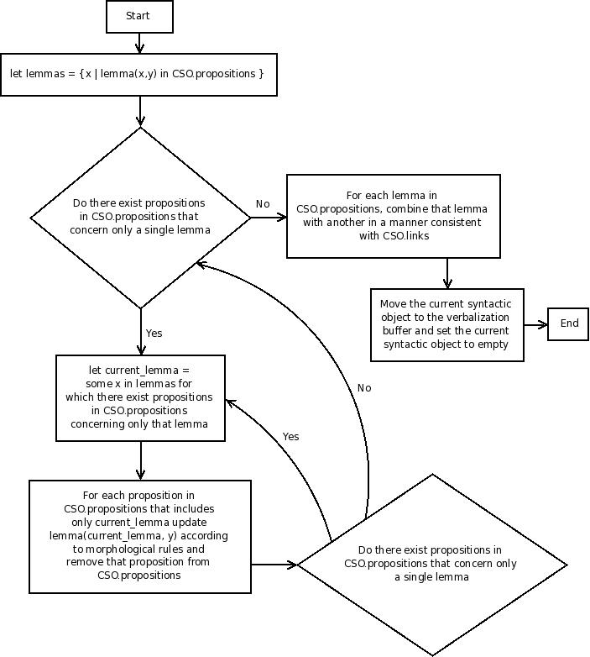

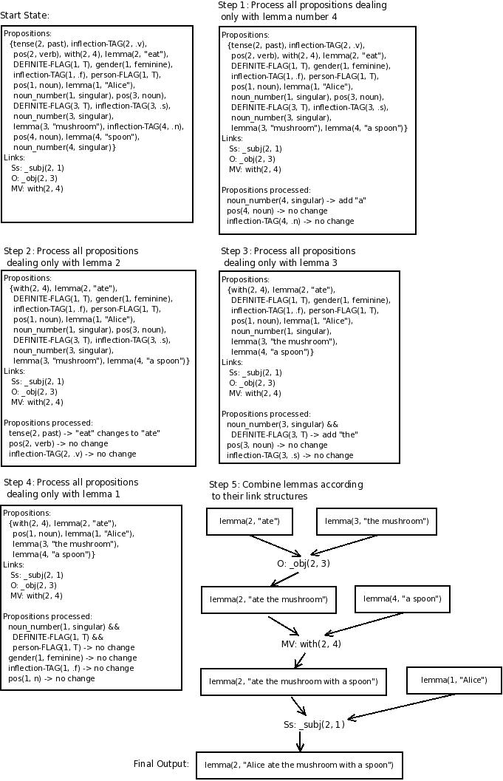
Figure 7. Linearization of “Alice ate the mushroom with a spoon”

SPELLOUT
The final process to be described is SPELLOUT. It is the operation that determines whether or not a preverbal message in the verbalization buffer is ready for articulation and is also responsible for forming the articulation plan. SPELLOUT will select a preverbal message for articulation if two conditions are met: First, the preverbal message must have fulfilled all required links. This ensures that, for example, a transitive verb will not be articulated if it does not yet have an object. It will, however, articulate preverbal messages that have unfulfilled optional links. This choice facilitates the early commit strategy.
Second, in order to be chosen for articulation, a preverbal message must be capable of linking with what has already been articulated. If nothing has yet been articulated, a preverbal message must be capable of starting a sentence. If something has already been articulated, a preverbal message must be able to link with one of the unused optional links of the already articulated content. SPELLOUT will also periodically check to ascertain whether or not the end of sentence marker can be attached to what has been articulated. If so, then SPELLOUT will identify the end of a sentence and append the right wall.

Limitations and Future Work
This design does not explicitly incorporate error correction, although its architecture allows for it. The ability for an incremental system to make mistakes and correct them is one of its major strengths. This ability will be one of the areas worth pursuing in the future. NLGen2, as presented in this paper, is designed so that incorporating error correction will be possible without changing much, if any, of the existing architecture.
Finally, the assumption that a lemma will be present for every preverbal message is a large one. One of the primary tasks for language generation is to determine which concept maps to a particular concept. Although in the small domain examples given by Guhe a specific word form/concept pair is generated, this will not always be the case in real world situations. Future versions of NLGen2 will incorporate lemma identification so that lemmas will be retrieved from link grammar’s dictionary based upon incomplete semantic content, as well as based upon partial relational content.
Conclusion
This paper has presented the design of a natural language generation module for integration with the RelEx system in the OpenCog framework. Motivations for the design from both psychology and linguistics were given. The overall architecture was described as well as the major operations and a running example was used to illustrate the system’s operations. Its advantages include a basis in psychological reality, scalability, and an incremental processing design that enables an early commit strategy. NLGen2 will serve as the base for a research program that will lead to a robust incremental language generation module.

References
Bechhofer, S., F. van Harmelen, J. Hendler, I. Horrocks, D. L. McGuinness, P. F. Patel-Schneider, and L. A. Stein: 2004, “OWL Web Ontology Language Reference”. W3C Recommendation. Available at http://www.w3.org/TR/owl-ref/.
Chomsky, N.. 1995. The Minimalist Program. MIT Press, Cambridge, MA.
Chomsky, N.. 2005. “On Phases”, Ms., MIT.
Culicover, P. W., & Jackendoff, R. (2005). Simpler Syntax. Oxford: Oxford University Press.
Fundel, K., Kuffner, R., and Zimmer, R. “RelEx–Relation extraction using dependency parse trees”. Bioinformatics, 2007, 23(3):365–371.
Guevara, E. “Binary Branching and Linguistic Theory: Morphological Arguments”. In: Picchi, M.C. and A. Pona (eds.) Proceedings of the “XXXII Incontro di Grammatica Generativa”, Firenze, 2–4 March 2006. Alessandria: Edizioni dell’Orso, 93–106. 2007.
Guhe, M. 2007. Incremental conceptualization for language production. Lawrence Erlbaum, Mahwah, NJ.
Hart, D. and Goertzel, B. 2009. “OpenCog: A Software Framework for Integrative Artificial General Intelligence”, available online at www.agiri.org/OpenCog AGI-08.pdf
Klyne, G., and Carroll, J.J. “Resource Description Framework (RDF): Concepts and abstract syntax”. W3C Working Draft, 2003. Available at http://www.w3.org/TR/2003/WD-rdf-concepts-20030123.
Lasnik, H. and J. Uriagereka. 2005. A Course in Minimalist Syntax. Blackwell.
Levelt, W. J. M. 1989. Speaking: From intention to articulation. MIT Press.
Newell, A. (1990). Unified Theories of Cognition. Cambridge, Massachusetts: Harvard University Press.
Pylyshyn, Z.W. Computational cognition: Toward a foundation forcognitive science. Cambridge, MA: MIT Press. 1986.
Reiter, E. and Dale, R. 2000. Building natural language generation systems. Cambridge University Press.
“SegSim” OpenCog Wiki. http://opencog.org/wiki/NLGen . 19 Aug, 2009.
Shieber, S. “A uniform architecture for parsing and generation”. In Proceedings of the 12th International Conference on Computational Linguistics, pages 614-619, Budapest, Hungary. 1988.
Sleator, D. and Temperley D. 1995. “Parsing English with a Link Grammar”. Carnegie Melon Technical Report.

